GP Request for Laboratory Services  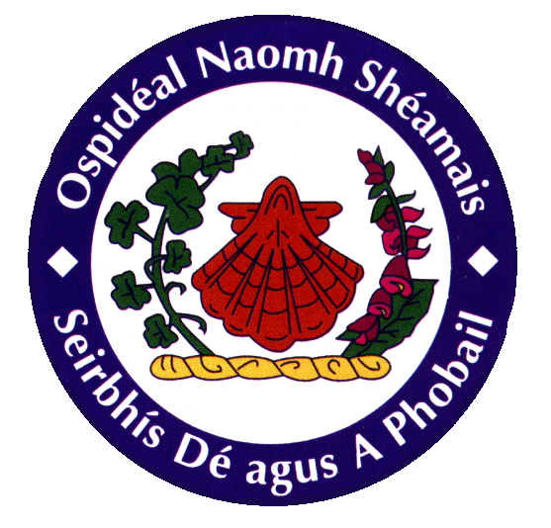  HISTOPATHOLOGY DEPARTMENT  Central Pathology Laboratory,  St. James’s Hospital, Dublin 8.  Tel.: 4162063 | Date/Time Received:
FOR LABORATORY USE ONLY
PLEASE AFFIX SPECIMEN NUMBER
BARCODE LABEL HERE
Patient Details (Complete Fully OR Attach an Addressograph Label inside the dotted line below):
Surname Maiden Name (if relevant):

First Name

Date of Birth / / Male Female Pregnant: Yes / No / Unknown
Patient’s Home Address:

Doctor’s Practice address or practice stamp here Practice Telephone Number:
Name Doctor’s
SJH Lab Code
Doctor’s This is mandatory to ensure the
Signature doctor can be contacted during
routine laboratory working
M.C.R.N. hours 8am to 8pm.
Clinical Details

Specimen Type

Previous Specimen? YES / NO

Date Taken: Time Taken:

N.B. Specimens should be placed in pots containing 10% Buffered Formalin and sent to the laboratory in a manner compliant with current ADR regulations.

Specimen requirements and other information is available on www.stjames.ie by clicking on the “Lab Services” Tab.

P904C Version 1

